CHAPTER 1
SheSync: Architecture and Exhaustive Rule-Level Verification of a Cross-Platform Self-Care Application for Menstrual and Endocrine Health
Vyom Varshney¹*, Vishal Gupta¹, Shivangi Yadav¹, Vanshika Singh¹
¹Department of Computer Science and Engineering (Artificial Intelligence), ABES Institute of Technology, Ghaziabad, Uttar Pradesh, India, Email Id-vyomvarshney2005@gmail.com
Abstract: Menstrual-health apps increasingly give advice from hand-written scoring rules that are seldom tested systematically. We present the architecture of SheSync, a React Native and Expo application for Android, iOS and the web, and an exhaustive verification of its analytics rules. One on-device routine turns a ten-item intake and daily logs into an archetype, a strain score, a workout-override state and anomaly flags for a clinician report. We ran the production TypeScript store, with only network calls stubbed, on all 19,800 combinations of intake profile, sensitivity and daily-log value. The score stayed in bounds and was monotonic in pain and mood, but light flow scored below spotting in 19.3% of comparable pairs, two code paths used different thresholds (6.9% of states), every state raised a severe or critical flag, and workouts were overridden in 83.0% of states. Five small refinements removed the first two defects, cut flags per state from 3.65 to 2.44 and override coverage to 65.9%, at under 1 ms per recomputation.
Keywords: Mobile health, Women’s health, React Native, Rule-based decision support, Software verification, Alert fatigue.
INTRODUCTION
Period trackers, used by tens of millions of people, are becoming self-care companions that interpret symptoms and recommend actions [1, 2]. When an app tells a user to rest instead of exercising or to show a report to a doctor, the rule behind that advice becomes part of her care, yet such rules are usually hand-written and tested on a few examples. Women’s health apps also handle data poorly: 20 of the 23 most popular shared user data with third parties [3].
SheSync is the authors’ cross-platform app for users with irregular cycles, painful periods or premenstrual mood symptoms; polycystic ovary syndrome alone affects roughly 6–10% of women of reproductive age [4], and premenstrual dysphoric disorder is a recognised diagnosis [5]. We contribute a description of its architecture and rules, an exhaustive method that verifies the production rule code against five properties, and a refined rule set checked with the same harness.
RELATED WORKS
Apps often fail irregular users, explain little about their methods [2] and disagree on the same histories [1]. SheSync’s workout override draws on the allostatic-load view of accumulated stress [6] and on evidence that heavy training with low energy availability can disrupt menstrual function [7]. Heart-rate-variability (HRV) metrics have defined norms when measured [8], which matters because SheSync estimates HRV-like values from self-report. In clinical decision support, more frequent and repeated alerts are accepted less often [9], so flag specificity is a design requirement. We apply complete enumeration, the simplest form of exhaustive state-space exploration used in formal methods [10], to an app’s health rules.
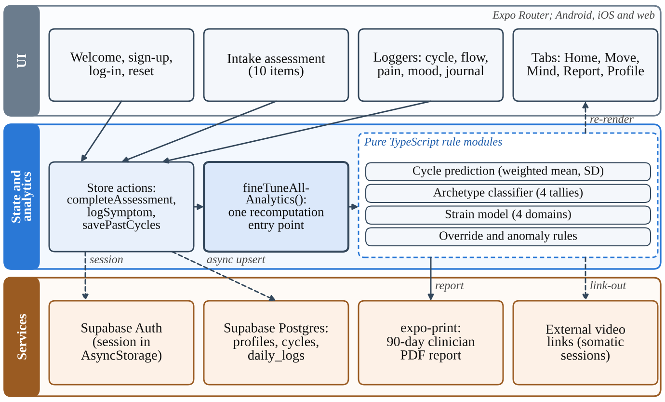
Figure 1. Three-layer architecture of SheSync. Every user action ends in one recomputation routine on the device; network calls are asynchronous and non-blocking.
PROPOSED WORK
3.1 Architecture
SheSync is written in TypeScript with React Native 0.86 and Expo SDK 57, using Expo Router (17 route files, 22 shared components, about 16,000 lines), NativeWind styling and Zustand state; one code base builds for Android, iOS and the web (Fig. 1). Health logic lives in pure functions, and every state-changing action, such as completing the intake, logging a symptom or saving cycles, ends in one routine, fineTuneAllAnalytics(), that recomputes all derived values, which makes the analytics deterministic and testable. Supabase provides e-mail authentication, with the session kept in AsyncStorage, and Postgres tables for profiles, cycles and daily logs; writes are asynchronous and failures are caught, so the app keeps working offline. The clinician report is exported as a PDF with expo-print; the manifest contains no advertising or analytics SDKs. Fig. 2 shows screens from the production web build.
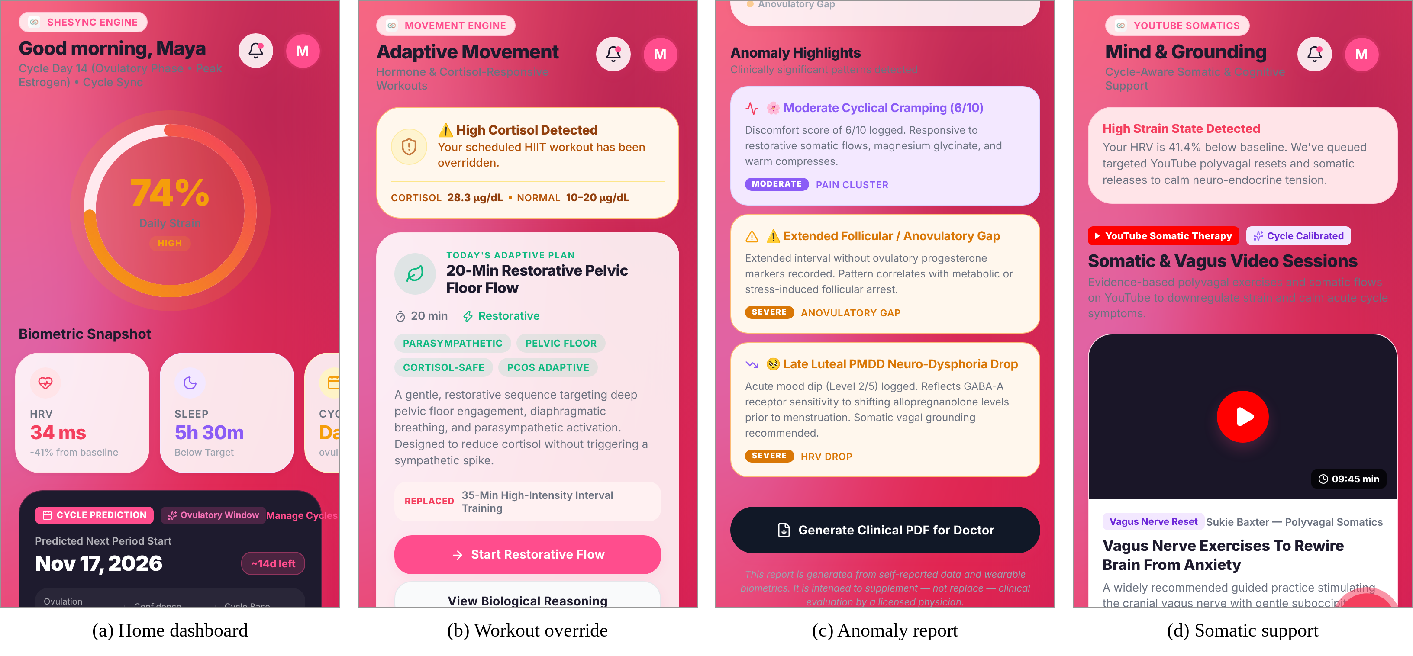
Figure 2. SheSync web build: (a) home dashboard with strain gauge, (b) workout override, (c) anomaly highlights with PDF export, (d) somatic support.
3.2 Intake Assessment and Archetypes
The intake has ten single-choice items in five chapters. Options add points to four tallies, PCOS, PMDD, cortisol sensitivity and strain sensitivity, and a first-match rule, also triggered by the matching goal answer, assigns an archetype: PCOS-oriented (tally ≥ 4 or long or irregular cycles), PMDD-oriented (tally ≥ 4 or severe premenstrual symptoms), restorative (cortisol or strain tally ≥ 4) or a general cyclical optimiser. The archetype sets defaults such as strain sensitivity and the sleep target.
3.3 Strain Score, Load States and Anomaly Rules
Each recomputation scores four domains: neuro-endocrine D_{N} (morning state, premenstrual symptoms, mood), pelvic D_{P} (3.3 × pain plus a flow-history term), flow D_{F} and recovery D_{R} (sleep, energy, regularity). The strain score is
S = clamp_{[10, 96]}( round( s_{a} (D_{N} + D_{P} + D_{F} + D_{R}) ) ) (1)
with s_{a} = 1.08, 1.00 or 0.92 for gentle, balanced or dynamic sensitivity and levels low (< 36), moderate (36–59), high (60–79) and severe (≥ 80). The load state (Fig. 3) is “high” if S ≥ 65, pain ≥ 7 or mood ≤ 2, replacing a scheduled high-intensity session with a restorative one; “elevated” if S ≥ 40 or pain ≥ 5, which in the deployed version also overrides; otherwise “normal”. The displayed HRV, sleep and cortisol indicators are model estimates from self-report, not sensor readings. Four rule groups (pain, flow or anovulatory gap, mood or autonomic strain, sleep) raise graded flags for the dashboard and the PDF report.
3.4 Verification Method
The production store was bundled with esbuild into a Node.js module, with only the Supabase and PDF services stubbed. A harness resets the store, applies an intake profile and sensitivity, injects one daily log and calls fineTuneAllAnalytics(). The input space is enumerated completely: five intake profiles (none, PCOS-type, PMDD-type, high-stress, low-risk) × three sensitivities × 11 pain × six flow × five mood × four energy values, or 19,800 states. Five properties are checked: P1, S stays in [10, 96]; P2, S never falls when pain or flow rises or mood falls, on every adjacent pair; P3, level labels agree across code paths; P4, flags are specific; and P5, overrides are selective. As the inputs are discrete and the enumeration complete, P1–P3 are established exactly.
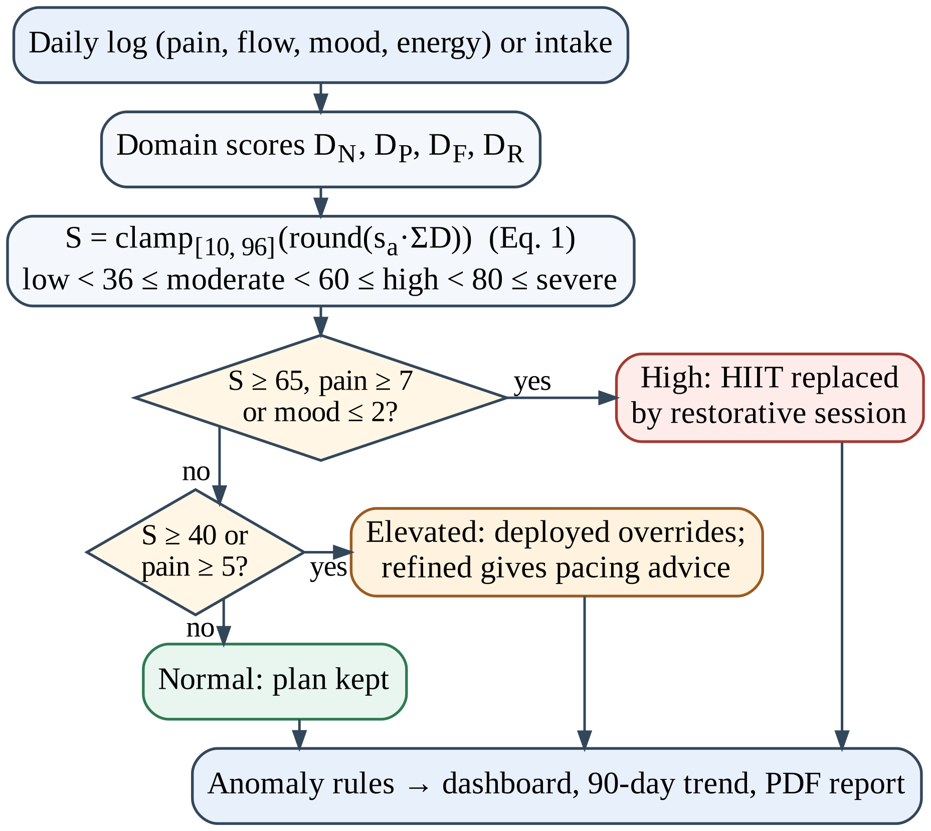
Figure 3. Decision flow from a daily log to the strain score, load state and anomaly flags.
RESULT AND DISCUSSION
4.1 Verification Findings
The score respected its bounds and never fell with more pain or lower mood (Table 1), but three issues appeared. The flow domain has no branch for “light”, a category the flow logger offers, so light flow scores 0 points while spotting scores 2, lowering the score in 3,179 of 16,500 pairs. The recomputation routine labels levels at 36/60/80 while a separate setter uses 38/62/82, so 6.9% of states are labelled differently depending on which path last wrote the score. Flags were not specific: every state produced a severe or critical flag, 3.65 per state on average, because completing the intake seeds every user’s condition list with both PCOS and PMDD, triggering a severe anovulatory-gap flag for everyone, and because the “normal” branches of three rule groups still emit moderate cards. As frequent alerts erode responsiveness [9], this matters most. Overrides covered 83.0% of states, triggered first by S ≥ 65 (5,368 states), pain ≥ 7 (4,114), mood ≤ 2 (3,532), S ≥ 40 (2,506) or pain ≥ 5 (909).
Table 1. Verification of the deployed and refined rules over 19,800 enumerated states.
Property | Deployed rules | Refined rules
P1 S within [10, 96] | Holds (10–96) | Holds (10–96)
P2 Pain monotonic (18,000 pairs) | 0 violations | 0 violations
P2 Mood monotonic (15,840 pairs) | 0 violations | 0 violations
P2 Flow monotonic (16,500 pairs) | 3,179 violations (19.3%) | 0 violations
P3 States labelled differently by two paths | 1,375 (6.9%) | 0
P4 Mean flags per state | 3.65 | 2.44
P4 States with ≥ 1 severe or critical flag | 100% | 84.7%
P4 Low-risk mild-day states: mean flags | 3.25 | 0.58
P5 States with workout override | 83.0% | 65.9%

4.2 Refined Rule Set and Scenarios
Five one-line changes were re-verified on a copy of the store: light flow gets 4 points; conditions come only from logged evidence (an irregular forecast adds PCOS, mood ≤ 2 adds PMDD); “normal” outcomes become status text; “elevated” gives pacing advice only; and one threshold set labels levels. Table 1 shows the effect; for a low-risk user on a mild day (pain ≤ 3, at most light flow, mood ≥ 3) flags fall from 3.25 to 0.58. In persona runs, a low-risk user logging pain 2 received three cards, one severe, before refinement and none after; a user logging pain 9 was rightly overridden with a score of only 57, so the triggering clause should be shown with the override.
4.3 Runtime Cost and Limitations
Recomputation took 0.46 ms on average (95th percentile 0.64 ms) and cycle prediction 0.44 ms (Node.js v22, one 2.1 GHz Xeon core), far inside a 16 ms frame even on a phone ten times slower. The verification covers rule logic, not clinical validity; thresholds remain expert-chosen. HRV, sleep and cortisol estimates should be labelled as such or replaced by wearable data [8], and row-level security, a privacy notice and explicit consent are needed before release [3]. SheSync does not diagnose; its flags prompt a conversation with a clinician.
CONCLUSION
Keeping all health reasoning in one deterministic on-device routine made complete verification of SheSync practical: running the production rules on all 19,800 input combinations exposed four defects that example-based testing had missed, and five small refinements fixed or reduced each at no runtime cost. The harness can run in continuous integration; a consented pilot with users and clinicians is the next step.
CONFLICT OF INTEREST
The authors declare no conflict of interest.
ACKNOWLEDGEMENT
An AI assistant (Claude, Anthropic) helped draft the text, build the verification harness and prepare the figures; the authors verified all content and take full responsibility for the chapter.
REFERENCES
- Worsfold, L., Marriott, L., Johnson, S., & Harper, J.C. (2021). Period tracker applications: What menstrual cycle information are they giving women? Women’s Health, 17, 17455065211049905.
- Epstein, D.A., Lee, N.B., Kang, J.H., Agapie, E., Schroeder, J., Pina, L.R., Fogarty, J., Kientz, J.A., & Munson, S.A. (2017). Examining menstrual tracking to inform the design of personal informatics tools. Proceedings of the 2017 CHI Conference on Human Factors in Computing Systems, 6876–6888.
- Alfawzan, N., Christen, M., Spitale, G., & Biller-Andorno, N. (2022). Privacy, data sharing, and data security policies of women’s mHealth apps: Scoping review and content analysis. JMIR mHealth and uHealth, 10(5), e33735.
- Bozdag, G., Mumusoglu, S., Zengin, D., Karabulut, E., & Yildiz, B.O. (2016). The prevalence and phenotypic features of polycystic ovary syndrome: A systematic review and meta-analysis. Human Reproduction, 31(12), 2841–2855.
- Epperson, C.N., Steiner, M., Hartlage, S.A., Eriksson, E., Schmidt, P.J., Jones, I., & Yonkers, K.A. (2012). Premenstrual dysphoric disorder: Evidence for a new category for DSM-5. American Journal of Psychiatry, 169(5), 465–475.
- McEwen, B.S. (1998). Protective and damaging effects of stress mediators. New England Journal of Medicine, 338(3), 171–179.
- Mountjoy, M., Sundgot-Borgen, J.K., Burke, L.M., et al. (2018). IOC consensus statement on relative energy deficiency in sport (RED-S): 2018 update. British Journal of Sports Medicine, 52(11), 687–697.
- Shaffer, F., & Ginsberg, J.P. (2017). An overview of heart rate variability metrics and norms. Frontiers in Public Health, 5, 258.
- Ancker, J.S., Edwards, A., Nosal, S., Hauser, D., Mauer, E., & Kaushal, R. (2017). Effects of workload, work complexity, and repeated alerts on alert fatigue in a clinical decision support system. BMC Medical Informatics and Decision Making, 17, 36.
- Clarke, E.M., & Wing, J.M. (1996). Formal methods: State of the art and future directions. ACM Computing Surveys, 28(4), 626–643.

* Address correspondence to Vyom Varshney, ABES Institute of Technology, Ghaziabad, Uttar Pradesh, India; Email Id-vyomvarshney2005@gmail.com

